March Parent Email
Don’t miss this once-in-a-lifetime, joy-filled, Catholic celebration!

Saturday, June 8 - CHI Health Center, Omaha.

Over 7,000 have registered so far, and Youth Sessions are filling up fast.
Wee Unite (ages 4-6) is almost sold out!

Learn more about Wee, Junior and Teen Unite:
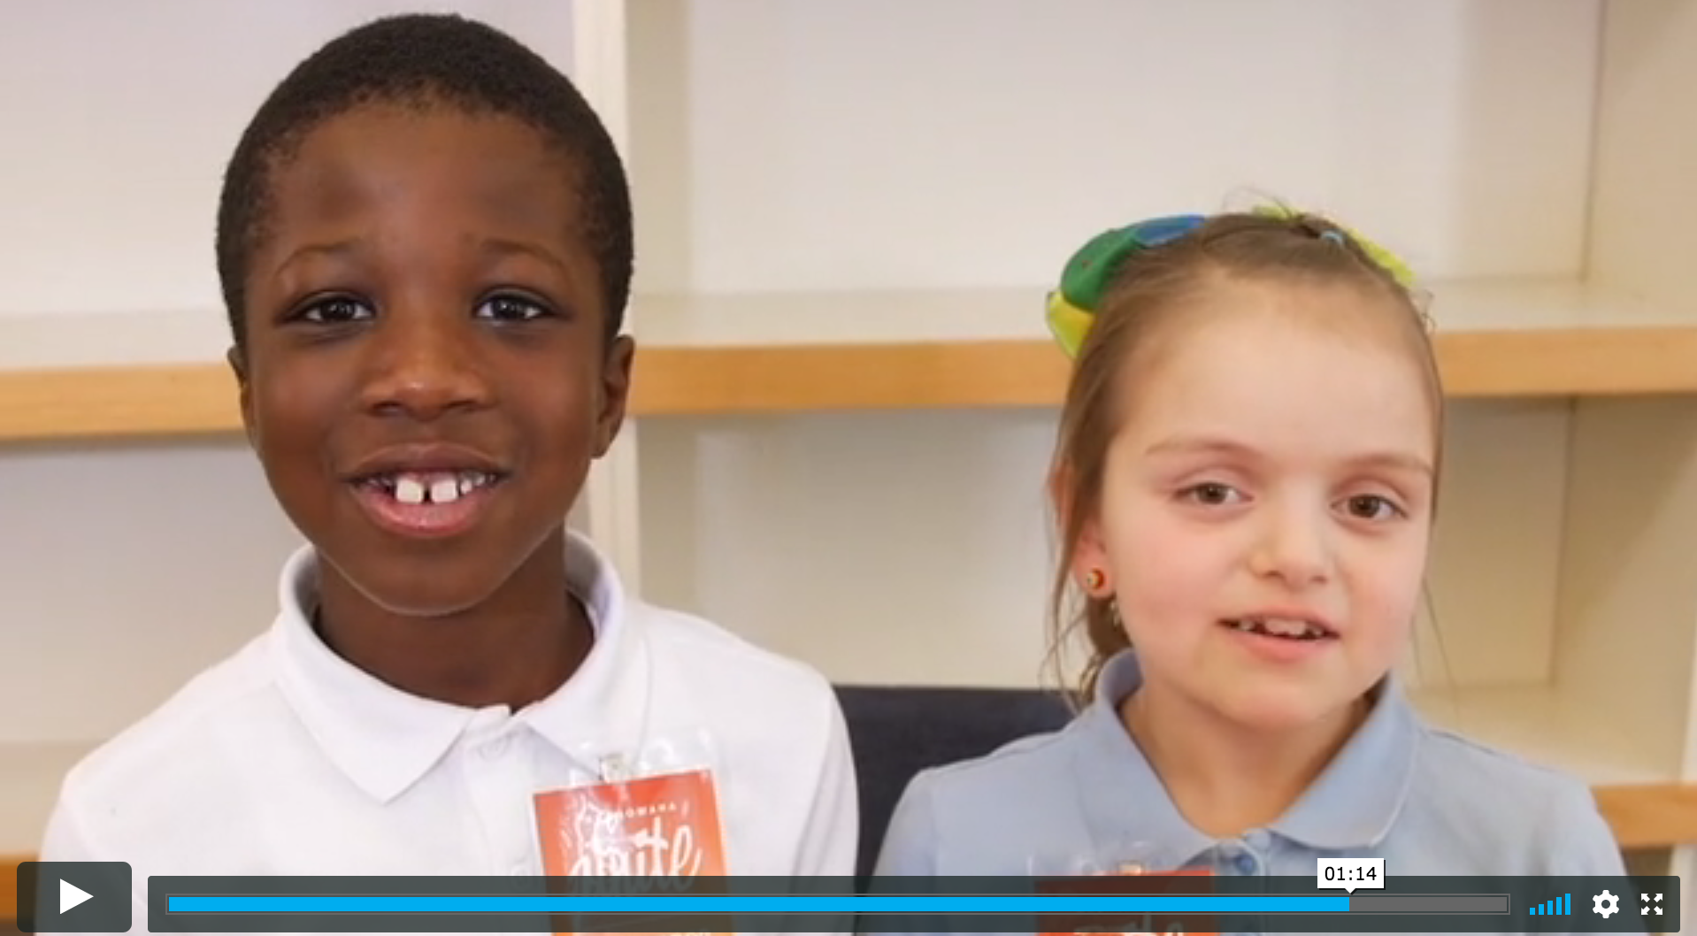

Admission is FREE but space is going fast, so register soon.

Thousands of Catholics from every corner of the archdiocese will gather together to celebrate ALL the things that make us who we are in the Archdiocese of Omaha through multimedia presentations, Cross and Light theatrical performance, comedy by Catholic comedian Jim Gaffigan, and Pentecost Vigil Mass with Archbishop Lucas.

You are far from ordinary.
Be part a of something extraordinary at ArchOmaha Unite!

