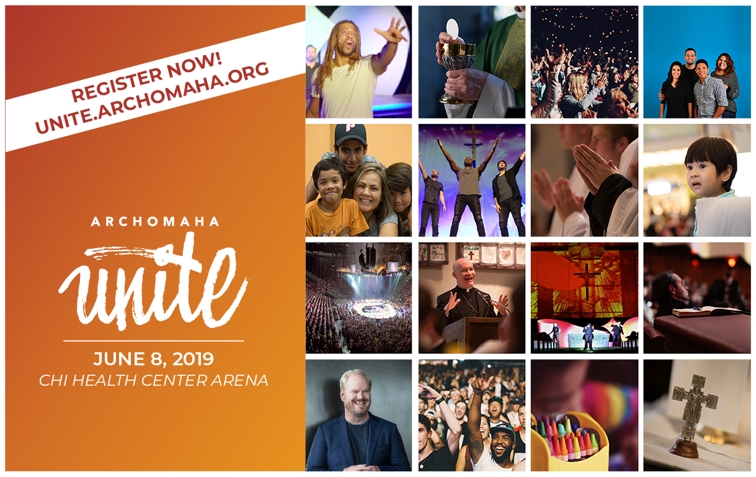

You are far from ordinary.
Be part a of something extraordinary at ArchOmaha Unite!

Saturday, June 8 - CHI Health Center, Omaha.

Admission is free, but space is limited. Save a place for you and your family at Unite by registering today.

Online registration is now open!

There is more!
You are more than what the world tells you. There is more to you, and there is more to your Catholic faith too.

June 8, 2019, experience your faith as you’ve never seen it before - in a vibrant, joy-filled, one-day Catholic celebration we call ArchOmaha Unite. Thousands of Catholics from every corner of the archdiocese will rally together to celebrate hope, family, community and ALL the things that make us ‘who we are’ in the Archdiocese of Omaha.

ArchOmaha Unite is about YOU and celebrating what makes you a unique and irreplaceable part of the Catholic Church in Northeastern Nebraska.

Event Highlights
- Multimedia Main Event featuring Q&A with Archbishop George Lucas, stories of faith from all over the archdiocese and a few surprises.
- Nationally-known Catholic Comedian Jim Gaffigan
- Cross and Light musical theater performance
- Breakout sessions for children and Spanish speakers
- AND Pentecost Vigil Mass with thousands of Catholics across the archdiocese!

What will the Youth Sessions be like?
While you experience the Main Event in the arena, your children will encounter Jesus through songs, games, motivational speakers, and more at Wee Unite, Junior Unite and Teen Unite. Learn more here or just watch the video!
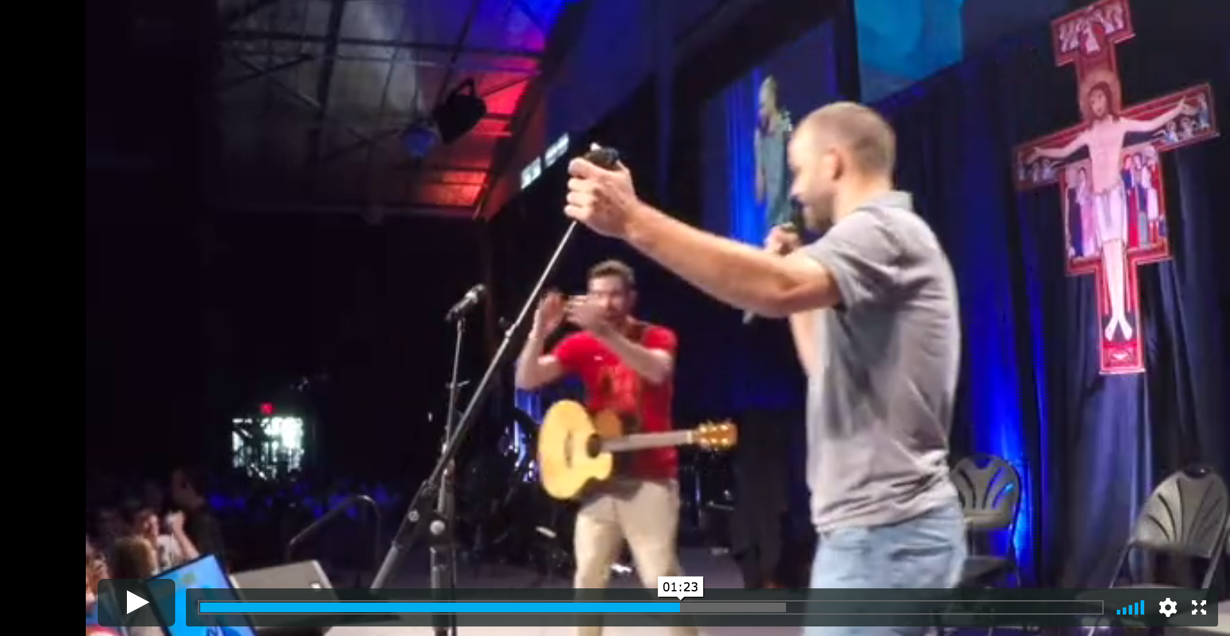

Don’t miss out on this once-in-a-lifetime event! Admission is free, but tickets will go fast, so save a place for you and your family at Unite by registering today! Register and learn more at unite.archomaha.org.

